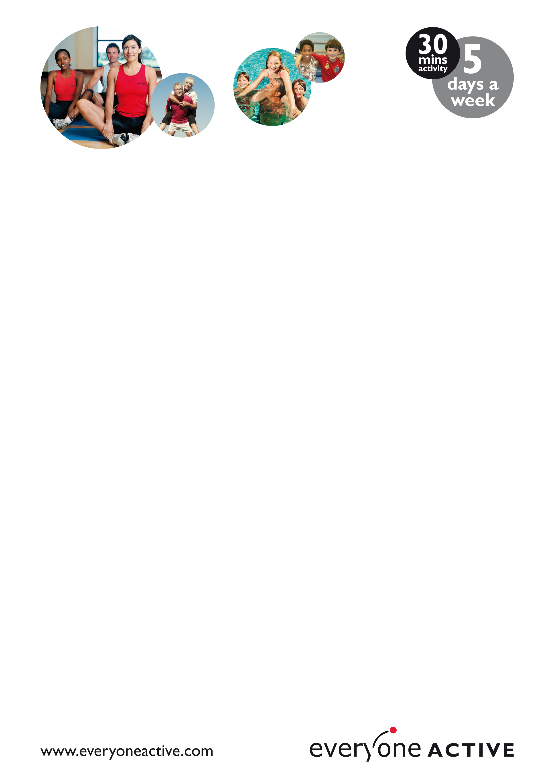

Welcome

Dear Parent/Guardian

Plymouth Life Centre would like to welcome your child to our Schools Swimming Programme.

Everyone Active School Swimming Lessons provide an ideal environment for your child to learn to swim, gain water confidence and try new aquatic skills within an intensive three week period.

The swimming lesson programme adheres to the ASA Learn to Swim Framework(Amateur Swimming Association) and National Curriculum Key Stage 2 skills(the guidelines set by the government as the standard level of swimming for primary school leavers).

The lessons are delivered by a highly trained and qualified team of teachers and assistant teachers, so you can be absolutely confident that we will provide your child with quality teaching, in a safe and fun environment.

Everyone Active School Swimming Lessons – Things you should know:

- Your child will attend a 30 minute lesson every morning for three weeks.
- Your child will be taught to swim, learns basic Water–Polo skills and in some cases experience diving and rookie lifeguard.
- Shoulder length or long hair should be tied up.
- All swim shorts must be above the knees.
- We ask for girls to wear one piece costumes
- We recommend all jewellery to be removed prior to the lesson.
- We do allow the use of goggles, however they must be removed for diving and water-polo sessions.
- All children will receive five free family swims, so the whole family can enjoy the benefits of swimming and participate in an activity together.

If you have any questions or concerns please do not hesitate to get in touch, we want your child to have a positive experience and will do what we can to accommodate any specific needs.

We hope your child enjoys their Everyone Active School Swimming Lessons at Plymouth Life Centre.

Thank You

Jessica Hogben

