Mary Dean’s C of E Primary School YR - Autumn 1 2021

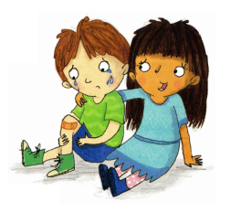  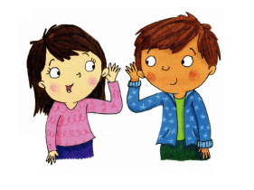  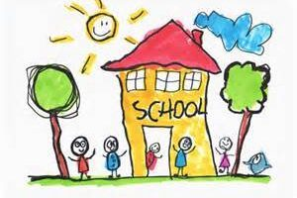  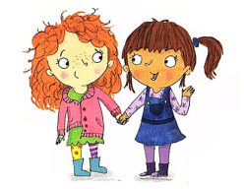  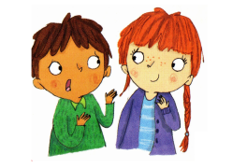  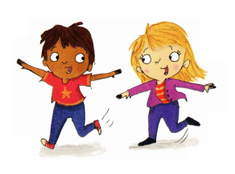  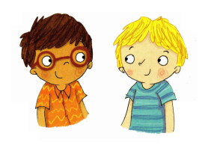  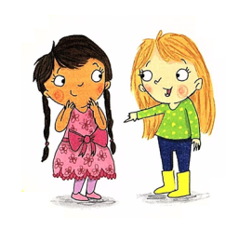  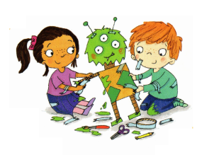  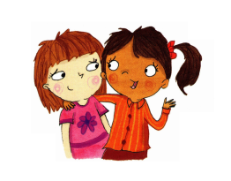  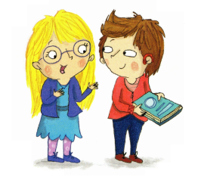 | Personal, Social and Emotional Development  - Settling in  - Settling-in  - What is a friend?  - How do I make friends?  - What can friends do together?  - What to do when friends  upset you?  - What makes good friends? | Vocabulary  We are learning to use  and understand these words:  friend, together,  play, share,  kind, help, teamwork,  feelings, happy, smile,  pleased, sad, lonely, cry, sorry, forgive, shy, care  mistake, talk/chat, laugh,  listen, care, truth.
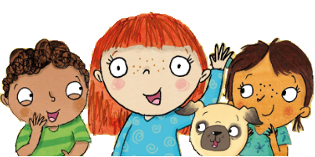
‘Friends’

Focus Text: My Friend Bear by Jez Alborough
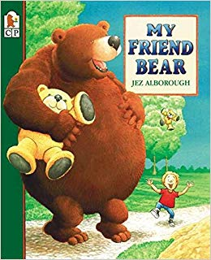
 |  | 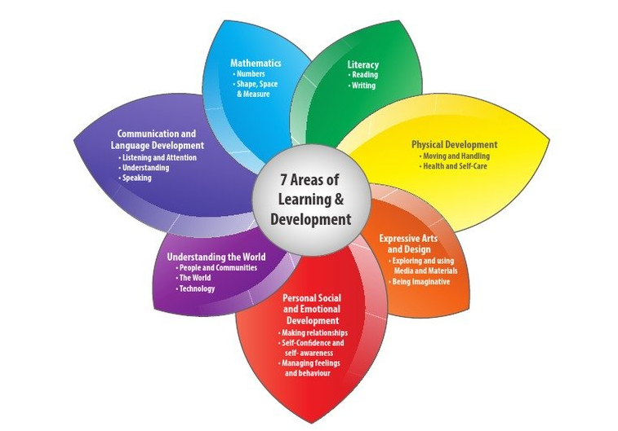

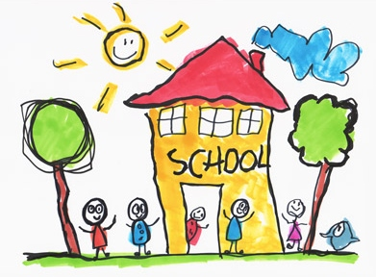
What makes good friends?
What to do when friends upset you
What can friends do together?
How do I make friends?
What is a friend?
Will you be my friend?

