Mary Dean’s C of E Primary School Reception - Summer 1 2022

As scientists, we will learn about:  *Different features of mini beasts including slugs, snails, worms, spiders, flies, caterpillars, butterflies, ladybirds and bees.  *The lifecycle of a butterfly.  We will learn to:  *Sort mini beasts into groups (wings/no wings, legs/no legs)  *Talk about and name parts of mini beasts (eg foot=snail, saddle=worm)  *Sequence pictures of the butterfly lifecycle.  Vocabulary we will learn and use:  Slither, foot, shell, wriggle, saddle, slime, trail, web, wings, cocoon, chrysalis, legs, antennae, lifecycle, nectar, honey. | Key Themes  At the bottom of your garden  Caterpillars and Butterflies  Slugs, Snails and Worms  Spiders and Flies  Ladybirds and Bees | As geographers, we will learn about:  *Bugs that live in different climates across the world  *How bugs create their own habitats (Ant hills) and how some are manmade (bug hotels)  *Caring for the environment and creatures within it  We will learn to:  *Recognise how some creatures live in different countries  *Create our own bug hotel  *Show care and concern for the environment and creatures  Vocabulary we will learn and use:  Bugs, insects, habitats, climate, country, manmade, natural, environment, care magnifying glasses, observe.
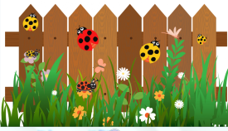
Bug Busters!
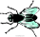  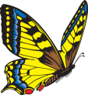  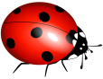  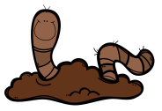  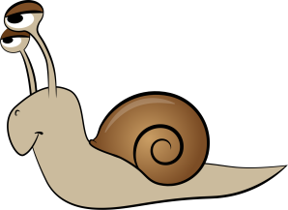 | Focus Text:  Mad About Minibeasts!  by Giles Andreae  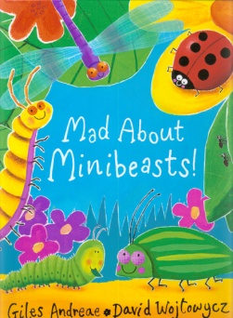 | 