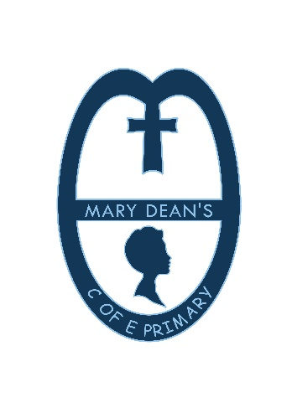
Mary Dean Avenue
Tamerton Foliot
Plymouth
PL5 4LS
01752 773521
Head Teacher: Mrs Tracey Jones B.Ed (Hons) NPQH office@marydeans.plymouth.sch.uk
_______________________________________________________________________________________________
11th November 2020
Dear Parents / Carers,
MENU CHOICE

CHRISTMAS DINNER - THURSDAY 10TH DECEMBER

Roast Turkey and Chipolata sausage or Quorn Roast with seasonal vegetables
****
Christmas Biscuit
Rudolph muffin
****
Christmas crackers

To help the cook cater for this special dinner please could you return the reply slip below to indicate that your child will be having this dinner. The cost will be £2.20 payable in advance online (via school money). If your child is eligible for universal or free school meals, there is no need to make any payment but please still return the slip below.
Please return slips by Friday 27th Novemeber

…………………………………………………………………………………………………………………………………………………………
CHRISTMAS DINNER - THURSDAY 10TH DECEMBER

Name:…………………………………………………….. Class:………………………………………..

I wish for my child to have a school dinner on Thursday 10th December.

Signed Parent / Guardian ………………………………………………………… Date: ………………………………………….

