Cycle 2 Summer 1 2022 RE- What do Christians believe God is like?
God | The creator and ruler of the universe and who we get our morals from.
parable | A very short story told to teach a moral or religious lesson.
Christian | A person who believes in the divine nature of Jesus Christ and follows his words and teachings.
Bible | The Holy book for the Christian faith.
believe | To accept something as honest or true.
message | Spoken or written information sent from one person or group to another.
miracles | A wonderful or amazing event or thing.
teachings | Something that someone believes to be true and teaches others.
faith | A belief or trust in something that has never been proved.
loving | Feeling or showing love.
father | A male parent.
forgiveness | The state of being likely or willing to forgive.
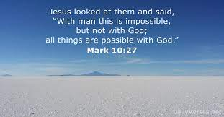

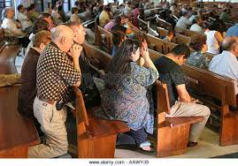

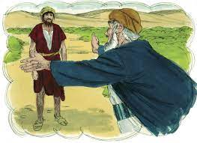

25.04.22  What do Christians believe God is like? | 2.05.22  What is the meaning of the parable of The Lost Son? | 9.05.22  How do Christians show their belief in God as loving and forgiving? | 16.05.22  How does the story of Jonah guide Christian’s beliefs about God? | 23.05.22  Can I say why Christians think it is important to sing about what God is like? | Assessment  Can I show what I think Christians are like?
Identify what a parable is. Tell the story of the Lost Son from the Bible and recognise a link with the concept of God as a forgiving Father. (parent)  Explain what Christians believe that God is like using clues from the parable and explore with the children that for Christians this parable teaches that God is loving and forgiving, like a parent. explaining reasoning.  Chn write on outline of a parent. Inside the outline write/draw what parents or role models do or say to show that they love their children. On the outside of the outline write/draw what pupils do or say to show that they love their parents. Explore the meaning that love goes both ways.  Outcome: Can say what God is like by comparing Him to a loving father. | Use drama to explore the differing perspectives and feelings of the father and both sons. Ask pupils to talk about their responses to the story: favourite character, most important moment, surprises, anything that made them laugh/smile or cry/sad. Explore and draw out the forgiveness and love shown by the father.  CH to make ‘hidden meaning boxes’. (each group makes a single box) The outside should show the literal story of the Lost Son, then they put the hidden meaning inside the box ready to be found by anyone who opens it- either using artwork or text.  Outcome: understand the deeper meaning of the story. | Explore what happens when things go wrong in school. (we apologise and forgive) Discuss what happens at home.  Talk about why it good to forgive people. Why/why not? How does it feel if you don’t forgive?  Why is it sometimes hard to forgive?  What do we think Christians pray for?  Explain that Christian prayers have four main types - praise, saying sorry, saying thank you and asking for something.  Chn try to write a short prayer saying sorry or saying thank you. (use Lost Son parable or real life situation)  Outcome: Understand that Christians pray to God to ask for thanks or forgiveness (He will grant it) | Tell the story of Jonah. What do they think Jonah must have been feeling at different points of the story? Was he scared or sorry, angry or worried?  What were the best bits? Most puzzling? Why? What were your feelings during the story? What do you think the story is about? Explain that this is not a parable, but there is a ‘hidden meaning’ in it, what might that be?  What happened when Jonah tried to run away from God? How did God find Jonah? Was it important for Jonah to go to Nineveh — why?  Chn in groups have a different part of the story. They decide how Jonah is feeling and what it might teach Christians. Make a wordbank/ class display of ideas that show what Christians learn from stories.  Outcome: Understand what Christians learn from stories. | What did we find out about God in the story of Jonah?  Discuss with pupils any times when they may have heard Christian hymns and songs. Why do you think Christians sing in church? Listen to two songs used by Christians in worship and explain that they help Christians to think about what God is like.  Look for important words.  Chn in groups have a section of a song to analyse. Discuss with class and write/draw what Christians can learn from song.  Outcome: Understand why singing is an important type of worship for Christians and what they can learn from them. | Ask: If God is invisible, how do Christians describe God?  What questions do you have about these ideas of God? You might get pupils to record some of these questions in thought bubbles.  Use a selection of questions to find out what children think God is like and how He helps Christians in their daily lives.  Produce writing (about one of the stories or comparing both)/art/ write a poem to show what they think they represent to Christians.  Outcome: show some understanding of what God is like/ what stories teach Christians/ how Christians have faith in God.

