Mary Dean’s Church of England Primary School
RSE (Relationships and Sex Education) Policy

Rationale and Ethos

This policy outlines our school’s approach to the planning and teaching of RSE to our children.

It has been produced in consultation with staff, Governors and parents.

RSE is an identifiable part of our personal, social, health and economic (PSHE) education curriculum, which has planned, timetabled lessons across all the Key Stages. This policy is therefore linked to (and should be read alongside) our PSHE policy as well as the school’s mission statement: ‘A school family, learning for life in all its fullness’.

Our school’s approach to RSE follows that of the Church of England Education Office in that it seeks to be faith-sensitive and inclusive.

We believe that all pupils have a right to an education which enables them to flourish and is set in a learning community where differences of lifestyle and opinion (within that which is permissible under UK law) are treated with dignity and respect; where bullying of all kinds is eliminated; and where children are free to be themselves and fulfil their potential without fear.

Our school seeks to ensure that the RSE curriculum protects, informs and nurtures all pupils. It clearly differentiates between factual teaching (biology, medicine, the law, marriage, different types of families and the composition of society) and moral teaching about relationships and values. We recognise that the distinction can be easily blurred. We plan to adopt/use recommended planning frameworks and materials (see below), which will help us to make informed judgements when teaching RSE . We will aim to teach RSE within a moral (but not moralistic) framework.

The intended outcomes of our programme are that pupils will:
- know and understand:
- What constitutes well-being and loving care for ourselves (Physical and Mental Health Education)
- How we show loving care for others (Relationships Education)
- (at an appropriate age) how we show loving care to those we choose to be intimate with, including within marriage (Sex Education*)
- how to enjoy strong positive, caring, relationships with good boundaries, online and in person
- to be appreciative of existing relationships++
- how to form new healthy friendships ++
- how to get help and treatment from sources such as the school nurse and other health and advice services, including reliable information online.

- Be able to:
- talk about their learning and progress confidently
- to reflect on values and influences (such as from peers, media, faith and culture) that may shape their attitudes to relationships and sex, and nurture respect for different views
- to disagree without being disagreeable
- to appreciate the lived experience of other people
- understand they have a right to:
- express their opinions freely (within the ground rules agreed by the teacher/pupils).
- to be heard
- to say ‘no’ when they feel uncomfortable or know that what is being asked of them is unsafe
- understand they have a responsibility to:
- try to ensure that they treat themselves and others, at all times and in all contexts, with dignity and respect ++
- foster equality (including gender equality) and challenge all forms of discrimination in RSE lessons and in every-day school life
- Try to live well together.
The RSE Curriculum
The Government has set out its expectations in terms of the teaching of RSE in Primary Schools. The statutory guidance can be found here: https://assets.publishing.service.gov.uk/government/uploads/system/uploads/attachment_data/file/805781/Relationships_Education__Relationships_and_Sex_Education__RSE__and_Health_Education.pdf

Our PSHE Curriculum fully satisfies the RSE requirements set out by the Government. We have used the PSHE Association’s Toolkit to help us to formulate our Programmes of Study and Schemes of Work (which are available to view on our website). We have adopted a spiral curriculum in order to ensure continuity and progression.
Local data and pupil/parent feedback from our PSHE theme week have been used to tailor our programmes of study to the children’s needs.
Details the RSE content which we plan to deliver to each phase in the school. Some of this content will be taught through the Science Curriculum. Please see Appendix 2
RSE Resources
To help us with the delivery of our curriculum we intend to use resources approved by The PSHE Association. These can be accessed and viewed by clicking on the links in our PSHE Scheme of Work (published on our website). We also plan to use the CWP Teaching RSE with confidence resource, which again has been approved by the PSHE Association. The overview for this scheme can be found in Appendix 3.

How will RSE be taught in our school?
RSE will be delivered professionally and as an identifiable part of PSHE. It will be led, resourced and reported to parents in the same way as any other subject. There will be a planned programme (see above) delivered in a carefully sequenced way.
Our RSE Curriculum will promote safe, equal, caring and enjoyable relationships and will provide opportunities for discussion about real-life issues (appropriate to the age and stage of pupils), including friendships, families, consent, exploitation and safe relationships online.
RSE will be delivered in a way that affords dignity and shows respect to all who make up our diverse community. It will not discriminate against any of the protected characteristics in the Equality Act and will be sensitive to the faith and beliefs of those in the wider school community. RSE teaching will seek to explain fairly the tenets and varying interpretations of religious communities on matters of sex and relationships and teach these viewpoints with respect. It will value the importance of faithfulness as the underpinning and backdrop for relationships. It will encourage pupils to develop the skills needed to disagree without being disagreeable, to appreciate the lived experience of other people and to live well together.
RSE will seek to build resilience in our pupils to help them form healthy relationships, to keep themselves safe and resist the harmful influence of the excesses of media in all its forms.
RSE will promote healthy resilient relationships set in the context of character and virtue development that sits within the schools Christian Vision and Values. (Our school values are: truthfulness, courage, friendship, forgiveness, thankfulness and responsibility).
Our RSE programme will be taught through a range of teaching methods and interactive activities using a range of high quality resources (see above). These will be regularly reviewed.
Teachers will aim to deliver lessons where pupils feel safe and will encourage participation by using a variety of teaching approaches, with opportunities to develop critical thinking and relationship skills.
Pupils will be encouraged to reflect and review their learning in RSE lessons.
Staff will encourage children to foster equality (including gender equality) and challenge all forms of discrimination in RSE lessons and in every-day school life
Learning about Relationships and Sex Education in PSHE education lessons will link to/complement learning in other Curriculum areas such Science, Computing, RE , PE and History.
Safe Practice
Our staff will be regularly trained in RSE and PSHE (with expert visitors invited in to enhance and supplement the programme where appropriate). Teachers will have regular opportunities to identify and request their training needs. This will form part of the Performance Management cycle.
It is likely that sensitive issues will arise in discussions. Where a member of staff is in doubt as to how to answer a question raised by a pupil, they will advise the pupil/class that they will need to seek guidance from the PSHE Coordinator/Head Teacher before answering.
Teachers are aware that effective RSE, which develops children's understanding of what is and what is not appropriate in a relationship, can lead to a disclosure of a child protection issue. In this event, staff will follow the guidelines set out in our Safeguarding Policy.
Pupils will be able to raise questions anonymously by ‘posting’ them in the class Question Box (Ask it in a Basket).
All staff teaching RSE will be supported by the PSHE Coordinator/Head Teacher.
Visitors/external agencies which support the delivery of RSE will be required to provide detailed plans of the content they intend to cover. They will also be required to share any resources they plan to use, prior to their visit.
The PSHE Coordinator/Head Teacher should be informed by teachers if they intend to invite visitor/external agencies into school to support their delivery of RSE.

Assessment
Pupils will be encouraged to reflect on their own learning and progress by completing baseline and endpoint assessments.
SEND Provision/Inclusion
Teachers will differentiate learning resources, where necessary, to meet the needs of all learners.
We will ensure that our RSE Curriculum is inclusive and meets the needs of all our children including SEND children. Class teachers will be responsible for ensuring that the RSE curriculum is accessible to children with SEND. Where it is deemed that elements of the RSE may not be appropriate for certain children the class teacher will consult with the SENDCO and ,where necessary, the SENDCO/Head Teacher will liaise with parents.
Parent Partnership
We view the partnership of home and school as vital in terms of informing the content of our curriculum and our provision for RSE.
We have worked in partnership with parents and carers, informing them about what their children will be learning and the resources we plan to use. We have also sought their views in terms of whether our curriculum is relevant to the needs of their children. This, we hope, will be an ongoing process. With this aim in mind, we plan to set up a Parent Working Group which will meet at regular intervals with the Head Teacher.
Following our annual PSHE theme week, all parents are asked for their feedback and suggestions. This is then used to assess the relevance of our curriculum.
We will notify parents when Sex education will be taught through the Science Curriculum.

Pupil Voice
We will gather pupils’ views about RSE so that teaching can be made relevant to their real lives and assessed and adapted as their needs change. Within ten broad topic areas (see Appendix 4), they will be asked which topics/subjects/issues are more important/are a priority. They will also be asked if there are other things (linked to RSE) that they think they should learn about.
At least once a year the children will be given a short questionnaire (appropriate to their age) to gather their views on the effectiveness and suitability of our RSE Curriculum.
Following our annual PSHE theme week, all children are asked for their feedback and suggestions. This is then used to assess the relevance of our curriculum.
The School Council will be asked to gather suggestions for ways to improve RSE teaching in our school.

Roles and Responsibilities
The RSE programme will be led by Mrs T Jones (Head Teacher) and Mrs G Brown (Y5/6 teacher)
It will be taught by confident, trained staff and only some elements will be taught by outside agencies (such as First Aid or aspects about puberty). It is important that pupils have confidence in the teacher and that a ‘safe space’ is created where pupils feel confident and can ask age-appropriate questions.
It will be supported by a link Governor
Monitoring and Evaluation
RSE will follow the same monitoring and evaluation processes used throughout the school for other subjects i.e. lesson observations, pupil conferencing, work reviews, learning walks etc.

Policy
Review
This policy will be reviewed every year
It was approved by FGB on: [date]
This policy should be read in conjunction with The Equalities Act 2010 https://www.gov.uk/guidance/equality-act-2010-guidance

APPENDIX 1.

https://www.marydeansprimaryschool.co.uk/new

APPENDIX 2

https://www.marydeansprimaryschool.co.uk/new

APPENDIX 3
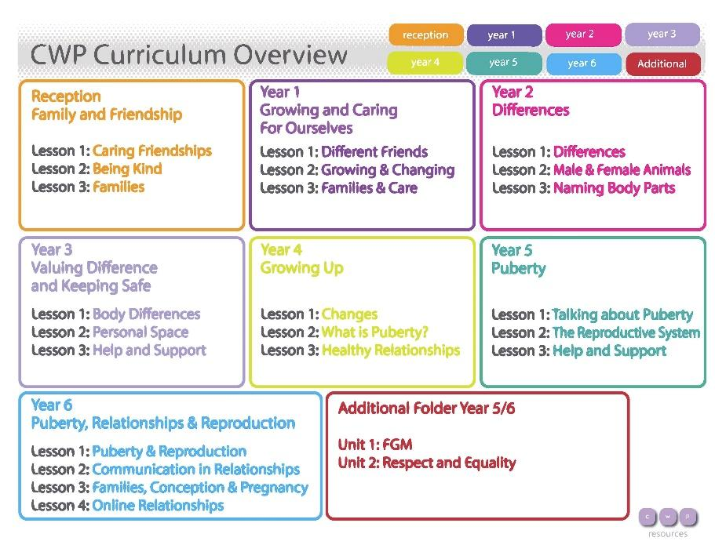

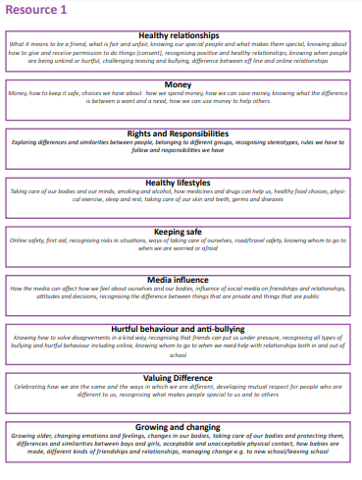
APPENDIX 4

PSHE Association 2018

