NCObjectives | Current | Key Knowledge and Vocabulary (New aims)
Pupils should be taught about:  - changes within living memory. Where appropriate, these should be used to reveal aspects of change in national life:  - events beyond living memory that are significant nationally or globally [for example, the Great Fire of London, the first aeroplane flight or events commemorated through festivals or anniversaries]  - the lives of significant individuals in the past who have contributed to national and international achievements. Some should be used to compare aspects of life in different periods [for example, Elizabeth I and Queen Victoria, Christopher Columbus and Neil Armstrong, William Caxton and Tim Berners-Lee, Pieter Bruegel the Elder and LS Lowry, Rosa Parks and Emily Davison, Mary Seacole and/or Florence Nightingale and Edith Cavell]  - significant historical events, people and places in their own locality. | - History of the Space Race- people, places.  - Chronology Lunar Timelines- putting events into chronological order  - Famous astronauts- moon landings- looking at Apollo Missions and in particular the moon landings.  - Memories of the moon landing.  - Tim Peake-History of Space exploration in the UK, first Briton in space. | Know …  - That animals went into space first.  - What the ‘Space Race’ was.  - The meaning of ‘orbit’.  - The meaning of ‘astronaut’ and ‘cosmonaut’.  - Names of first man and woman to ‘orbit’ earth.  - What the Apollo project was.  - Who were the first men on the moon.  - About the experiences of Tim Peake and Helen Sharman.  - What a space station is and what happens on it.  - What a satellite is.
Year 1/2 History. Cycle B. Spring term 2. 2022. Space- To infinity and beyond!

Orbit | Journey around a planet or moon.
Astronaut | Name given to someone who goes into space.
Cosmonaut | Russian name for someone who goes into space.
Spacecraft | A vehicle/machine that goes into space.
Satellite | A spacecraft that flies in space around the Earth.
Space station | A place in space where astronauts/cosmonauts live and work.
Apollo project | Space rockets that took humans into space and to the moon.
Space shuttle | Part of a rocket that could go into space and come back to Earth.
Lunar landing | Landing on the moon.
Moon walk | When an astronaut walks on the moon.
Lunar module | Part of a space rocket that lands on the moon.
Sputnik | Name of first satellite sent into space.
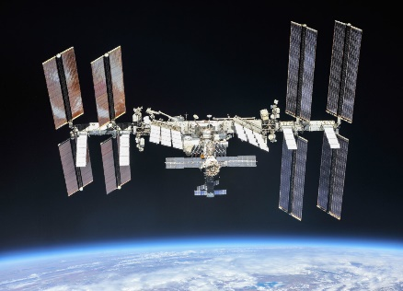
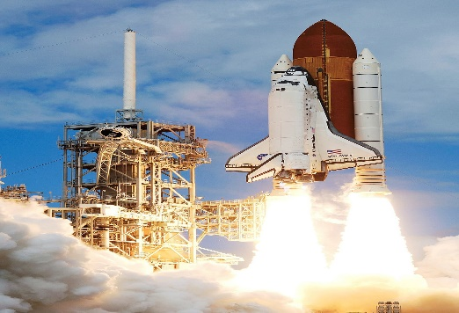
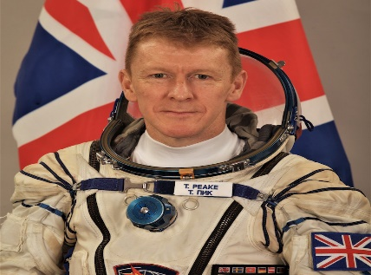
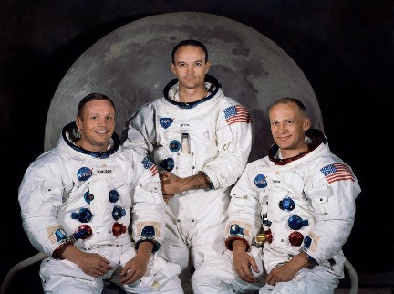
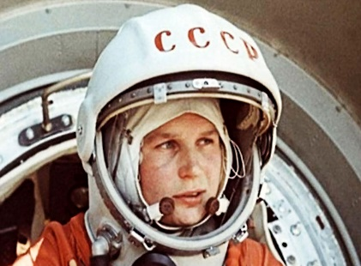

International Space Station

Helen Sharman
Images.

Space Shuttle

Tim Peake

Apollo 11 crew

Valentina Tereshkova
Vocabulary
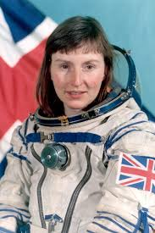
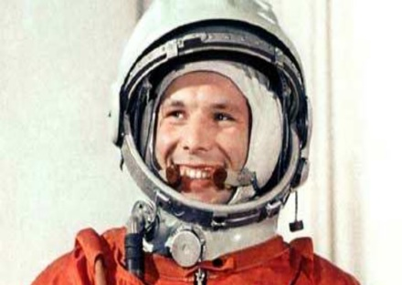
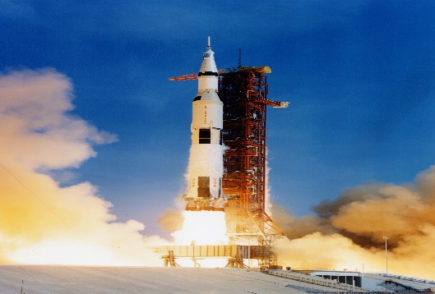
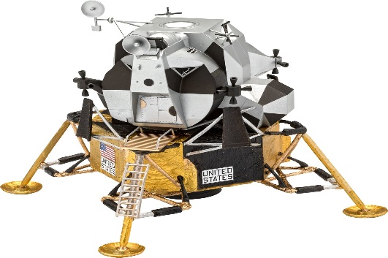

Yuri Gagarin

Apollo 11

‘Eagle’ lunar module.

