|  |
| --- |
| **Mary Dean’s CE Primary School – Year 5&6 Classifying Materials** |

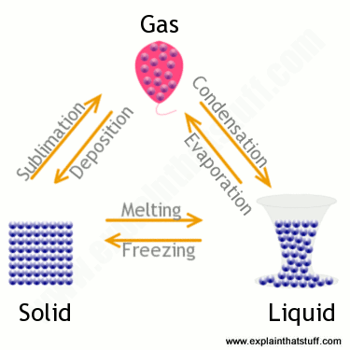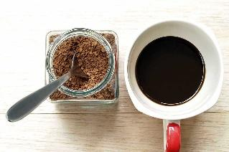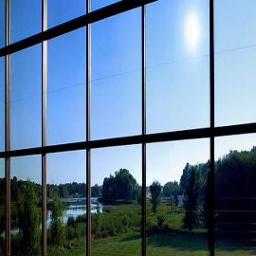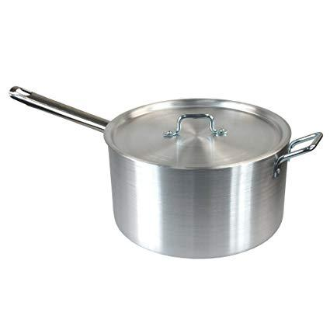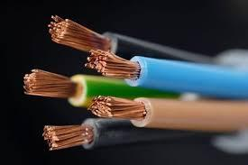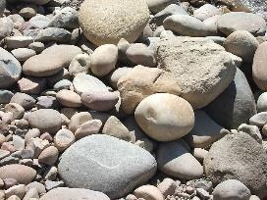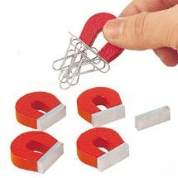

Burning

Reaction of acids (e.g. vinegar and Bicarbonate of soda)

Dissolving (e.g salt in water)

Mixing (e.g. rice and flour)

Freezing (e.g. water to ice)

Condensing (e.g. water vapour to water)

You can get the original materials back from a reversible change

It is impossible to get the original materials back

**Irreversible Changes**

**Reversible Changes**

Soluble

Transparent

Thermal Conductors

Electrical conductors

Hard

**Classifying Materials**

Magnetic

|  |
| --- |
| Vocabulary Dozen |
| |  |  | | --- | --- | | condense | Change from a gas or vapour to a liquid | | conductivity | The rate at which heat or electricity can pass through a material | | dissolve | Where a solid is incorporated into a liquid to become a solution | | evaporate | Turn from liquid into vapour | | freeze | Where a liquid is turned to a solid through lowering its temperature | | gas | A substance that has no fixed shape and moves freely to fill what contains it | | liquid | A fluid that flows freely | | material | The matter from which something is made. | | melt | Become a liquid through heating | | property | A quality or characteristic of something | | solid | A substance that is firm and stable in shape | | solution | Formed when a solid dissolves in a liquid. Contains a solute and a solvent. | |
|
|
|