Jesus | Jesus or Jesus Christ is the man who Christians believe was the son of God, and whose teachings are the basis of Christianity.
Incarnation | An incarnation is an instance of being alive on Earth in a particular form.
Gabriel | One of the archangels, the messenger of good news.
Mary | The mother of Jesus.
Joseph | The father of Jesus. He was a carpenter.
manger | A manger is a low open container which cows, horses, and other animals feed from when indoors.
journey | When you make a journey, you travel from one place to another.
Nativity | The Nativity is the story of the birth of Jesus.
Christmas | A Christian festival when the birth of Jesus Christ is celebrated. It takes place on the 25th of December.
Bethlehem | A town near Jerusalem in Israel which is the birthplace of Jesus.
angels | Angels are spiritual beings that some people believe are God's servants in heaven.
shepherd | Someone who looks after sheep.
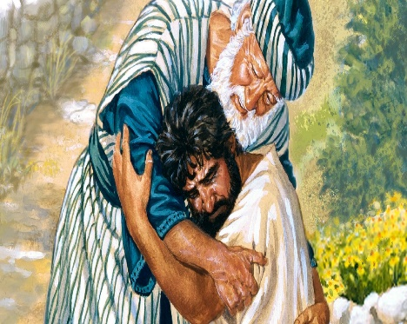
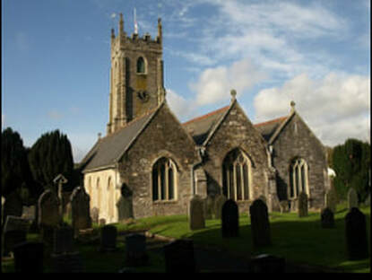
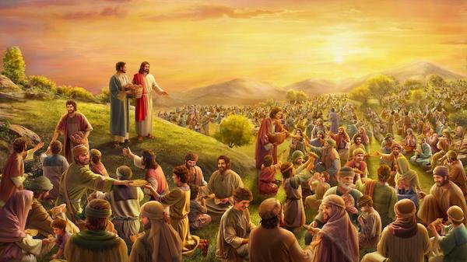
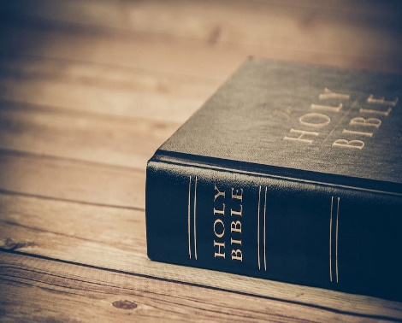
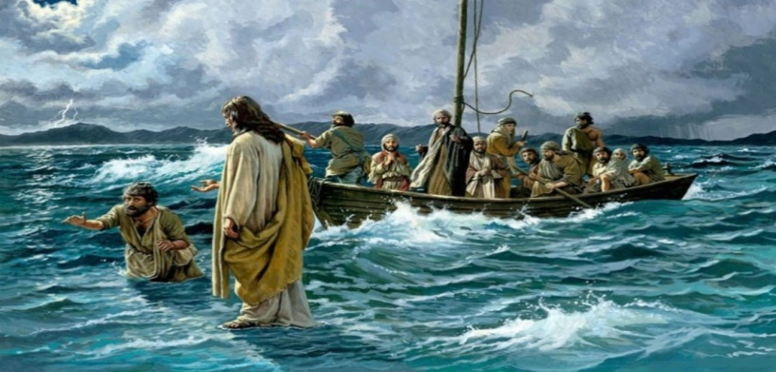
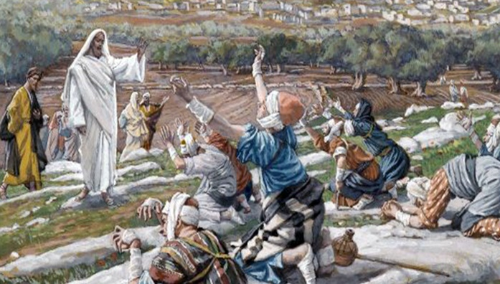
Year 1 and 2 Science Cycle 1 Spring Term 1 2021 Everyday Materials
CHANGE>>>>>>>>>>>>>>>>Images!!!!!!!!!!!!
Vocabulary Dozen
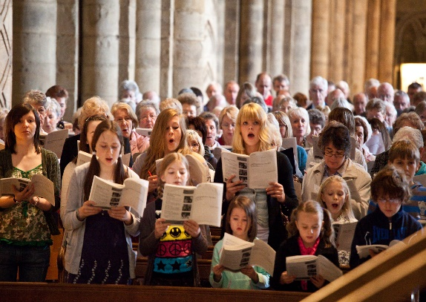
Week 1 | Week 2 | Week 3 | Week 4 | Week 5 | Week 6
What do we think about the baby Jesus?  Tell a familiar story (Beauty and the Beast) where someone who is not as they seem. Look at a picture of the baby Jesus. Explain that Christians believe that Jesus was a very special person.( God on Earth) Christmas celebrates Incarnation- God in the flesh. | How would we prepare for a new baby coming?  Discuss what you would need to get ready if there was a new baby arriving in your family. Talk about Jesus’ birth in the stable. (As God come to Earth) What were conditions like? Who visited? Discuss Jesus’ birth being good news (Luke) Who was it good news for and why? | What have I learned about the Nativity story?  Tell the story of the Nativity from Luke chapters 1 and 2. Set up stations: Gabriel visits Mary, journey to Bethlehem, Jesus born and placed in a manger, angels appear to shepherds, shepherds visit Mary. Children visit each station and retell that part. (record on ipad) | Can I retell the Nativity story?  Using the story stations from last week, children to visit each station and draw a picture and write a simple sentence to explain each part. Read completed story to check that it is in sequence and makes sense. Discuss their feelings about the story. | What links can I find to the Nativity in Christmas cards?  Look at a selection of Christmas cards. Which ones have got a clear link to the story in Luke? Ask children to explain the links.  Draw a Christmas card design linked to the Nativity story. What might you write inside? Think about messages of peace, thankfulness, kindness and love. | What signs can I find in church or elsewhere about Jesus’ birthday?  Visit a church/ invite in a local vicar to explain what will happen at church around Christmas time. Find out what colours the vicar might wear and what signs might they see and why are these important to Christians?  (may need to swap these last 2 weeks around due to timing)

Agreed syllabus outcomes for unit:
Teachers will enable pupils to achieve these outcomes, as appropriate to their age and stage, so they can:

Make sense of belief | Understand the impact | Make connections
- Recognise that stories of Jesus’ life come from the Gospels  - Give a clear, simple account of the story of Jesus’ birth and why Jesus is important for Christians | - Give examples of a way in which Christians use the story of the Nativity to guide their beliefs and actions at Christmas | - Think, talk and ask questions about Christmas for people who are not  - Decide what they personally have to be thankful for, giving a reason for their ideas

