Mary Dean’s CE Primary School – Year 5&6 Mountains, Volcanoes & Earthquakes

The Earth | Parts of a mountain | Vocabulary
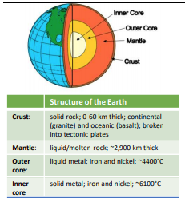 | 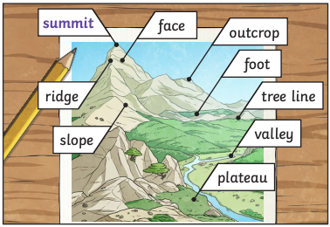 | maritime Connected with the sea  slave A person who is the legal property of another and is forced to obey them  trafficked Deal or trade in something illegal  empire A group of states or countries ruled over by one monarch  armada A fleet of warships  circumnavigation Sailing all the way around something (usually the world)  piracy Attacking and robbing ships at sea  New World The Americas and Oceania discovered by European explorers in the 1500s  merchant A person involved in trade  privateer A person authorised by a government or monarch to act in war  MOUNT EVEREST  - Earth’s highest mountain above sea level  - Located in the Himalayas  - 8,848m high  - First climbed by Edmund Hillary and Tenzing Norgay in 1953  - Located on the border between China and Nepal  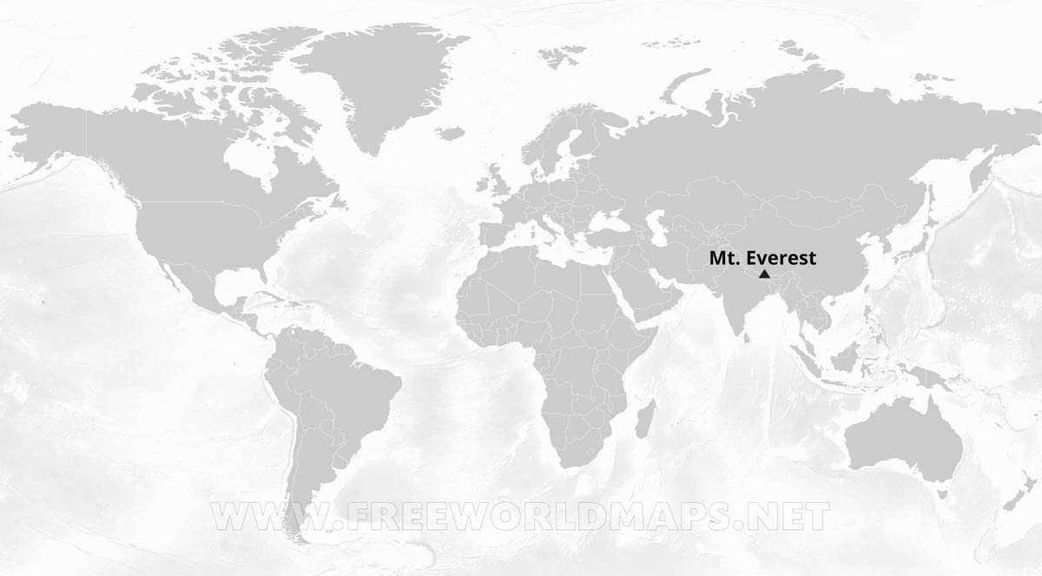  MOUNT SNOWDON  - Highest mountain in Wales, 3rd highest in Britain  - Located in Snowdonia National Park  - 1,085m high  - Over half a million people climb Snowdon every year  - Located in North Wales
The Tudor monarchs
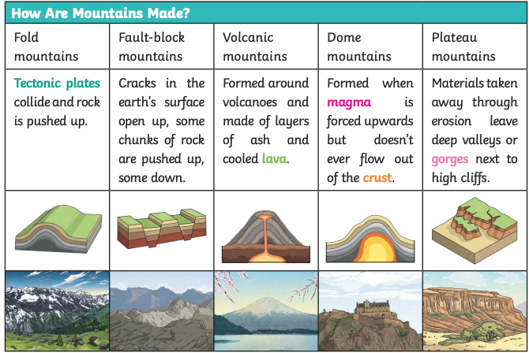
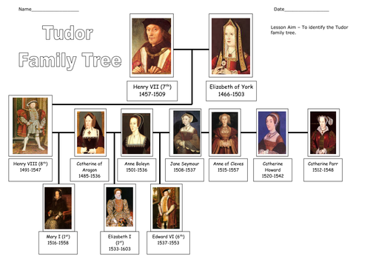
Volcanoes | Earthquakes
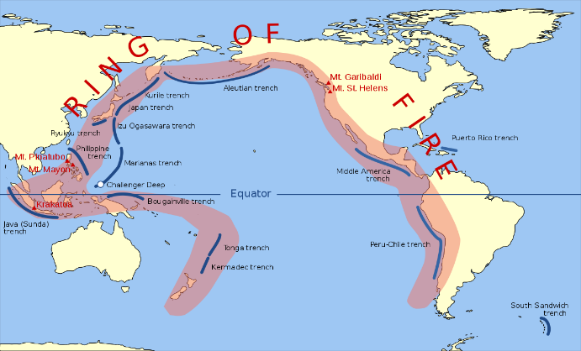  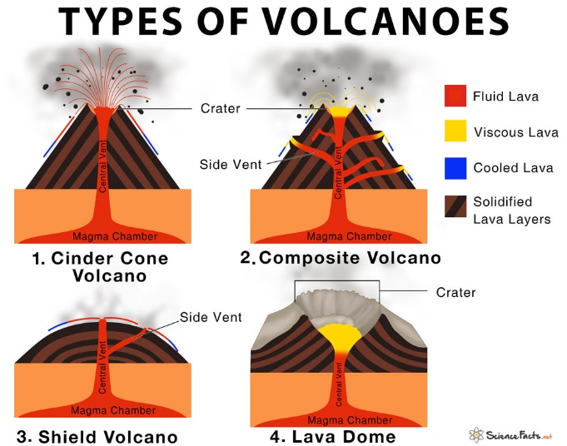  Kilauea volcano on Hawaii is the world's most active volcano, followed by Etna in Italy and Piton de la Fournaise on La Réunion island. | 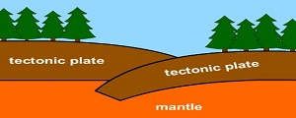  Earthquakes are caused by movements within the Earth's crust and uppermost mantle.  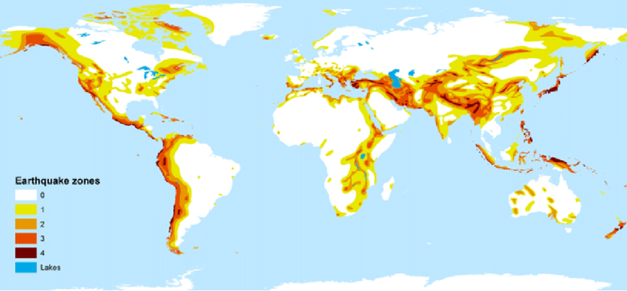  The map above shows the major earthquake zones of the world.  - Earthquake strength is measured on the Richter Scale  - The largest earthquake ever measured 9.4 on the Richter Scale. This was in Chile, South America in 1960

