***Knowledge Organiser Year 1***

***Seasides***

**Planning Links**

**Competencies**

Underlying the curriculum are our 4 Key Competencies

1. Communication 2. Creativity 3. Critical Thinking 4. Collaboration

Children have the opportunity to develop these across the curriculum.

**Key Historical Information (knowledge):**

* There are **differences** between seaside holidays **100 years ago, 50 years ago and today** e.g. different clothes and different entertainment. People got changed in special **bathing machines**.
* Some things are **the same** as today – children played with **fishing nets, buckets and spades, ate icecream and watched Punch and Judy** like today.
* We can find out about seaside holidays in the past from a range of **sources** including: photographs, film recordings, postcards, letters, diaries, paintings, books and first- hand accounts (talking to people).
* In Victorian times **most people travelled by train** to the seaside because during this time the **railways expanded** (grew) and went to more places.

**In Geography we will be learning about:**

* The physical geography and human geography of a coastal area in the UK
* The seas around the UK, the name and location of seaside towns in the UK and the location of the nearest seaside town to London.
* How to identify the human and physical features of a costal location using maps, satellite images and photographs

**To support our learning we will be:**

* Visiting the seaside to look at some of the human and natural features.
* Visiting the Aquarium to learn about the natural habitats of the seashore.
* Visiting the Museum of Childhood to find out about seaside holidays in the past.

**Key History Skills:**

I can:

* put pictures, artefacts or events in chronological (time) order
* use words and phrases such as old, new, a long time ago, before and after to describe the past
* use stories to ask and answer questions about the past

**In History we will be learning about:**

* How holidays to the seaside have changed in the last 100 years.
* To identify key period features of seaside holidays including clothes, travel and entertainment.
* To identify similarities and differences between seaside holidays in the past and present.
* How to use sources of evidence to find out about Victorian seaside holidays.
* The reasons Victorians went on seaside holidays.
* How the past can be divided into different periods.

**Key Geography Skills:**

I can:

* describe some of the physical features of a location?
* answer some questions using different geographical resources

**Key Geographical Information (knowledge):**

* The **seas** that surround the British Isles are: the **English Channel**, the **North Sea**, the **Irish Sea** and the **Atlantic Ocean**.
* There are many **towns** around the coast of the UK that are popular **seaside holiday locations** (see map below).
* There are **human features** such as a harbour, lighthouse, pier and promenade that we can see at seaside locations.
* There are **natural features** such as cliffs, caves, bays, stacks and beaches that we can see at seaside locations.

**Natural Features of Coastal Areas (Key Vocabulary)**

[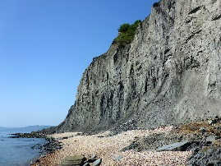](https://www.uksouthwest.net/dorset/lyme-regis-charmouth-seatown/wear-cliffs-pebbles.html) 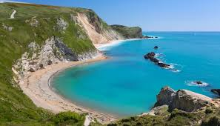 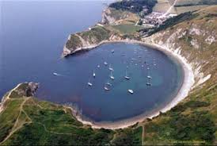 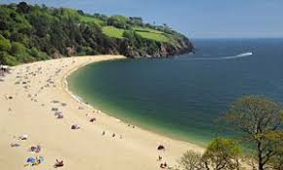 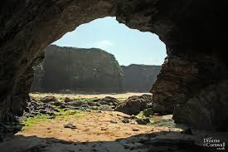 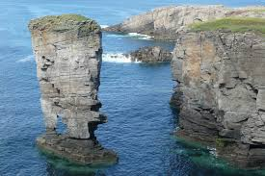 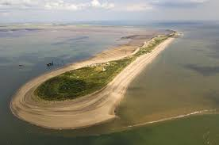

cliff coast bay beach cave stack spit

**Human (man made) Features of Coastal Areas (Key Vocabulary)**

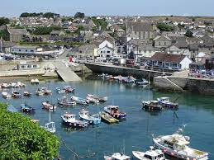 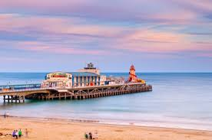 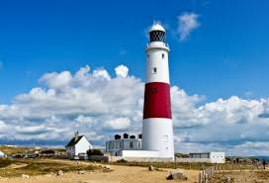 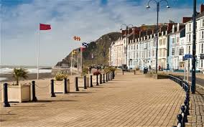 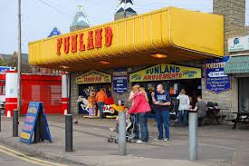 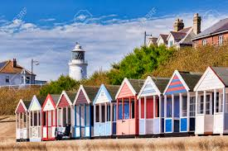

harbour pier lighthouse promenade amusements beach huts

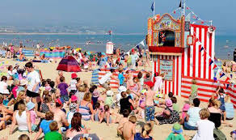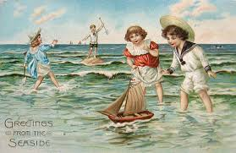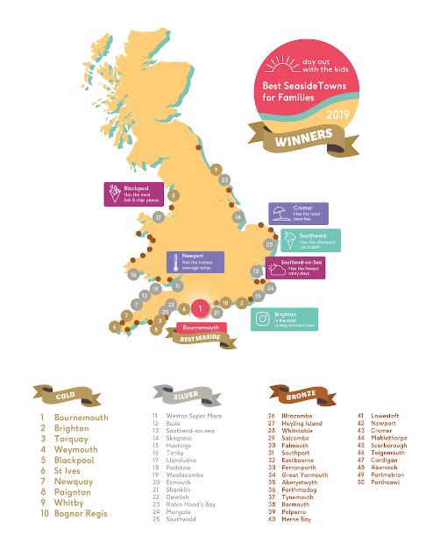 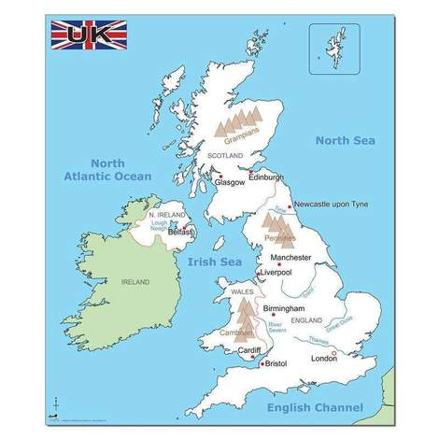 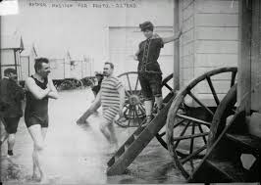 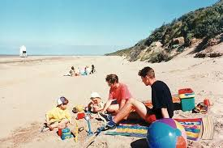

Map of Seaside town locations Seas around the UK Victorian Seaside in the past Seaside holidays in the present (today)