NCObjectives | Current | Key Knowledge and Vocabulary
- Name and locate the world’s seven continents and five oceans.  - Identify seasonal and daily weather patterns in the United Kingdom and the location of hot and cold areas of the world in relation to the Equator and the North and South Poles.  - Key physical features, including: beach, cliff, coast, forest, hill, mountain, sea, ocean, river, soil, valley, vegetation, season and weather.  - Use world maps, atlases and globes to identify the United Kingdom and its countries, as well as the countries, continents and oceans studied at this key stage.  - Use simple compass directions (North, South, East and West) and locational and directional language [for example, near and far; left and right], to describe the location of features and routes on a map. | - Can Identify and describe key components of the weather.  - Can I recognise key characteristics of very hot and cold places-compare to our locality.  - Can I locate the main oceans and continents of the world.  - Can I locate very hot and cold places and recognise key characteristics.  - Can I find out what meerkats are really like and create a simple map.  - Can I locate the Kalahari desert and use secondary sources to describe and locate it, make comparisons to Tamerton. | Know …  - Names and locations of 7 continents and 5 oceans-  Atlantic, Pacific, Indian, Southern, Arctic, North America, South America, Europe, Asia, Australasia, Africa, Antarctica.  - There are 4 seasons-spring, summer, autumn, winter.  - There are different types of weather-rain, sun, snow, clouds, temperature, hail, wind, rainfall  - That there are different climate zones around the world- tropical, sub-polar, temperate, polar.  - That UK is in a temperate climate zone.  - Position of climate zones.  - Where the north, south poles are.  - Where the equator is and what it is.  - The basic characteristics of each climate zone- hot, dry, high rainfall, low rainfall, cold, wet, humid.  - That each climate zone has different plant and animal life living in it.  - Some examples of plants and animals living in each climate zone.  - How the plants and animals are adapted to live in their respective climate zones.
Year 1/2 Geography. Cycle 2. Autumn term 1. 2021.

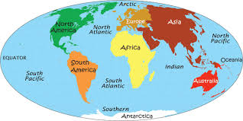
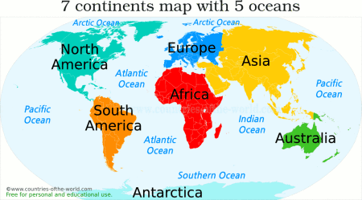
Map of world-continents and oceans
Vocabulary Dozen
Season | Main periods of the year that have their own weather- winter, spring, summer, autumn.
Climate | Weather that is typical of an area over a long period of time or in general.
Poles | Area at very top or bottom of the world. Cold and dry- North and South
Equator | Invisible line drawn around middle of planet, equidistant from each pole.
Temperate zone | Area of world whose general weather conditions vary across a wide range of temperatures and rainfall levels. Clear seasons.
Tropical zone | Area of world whose general weather conditions mean it is normally hot and wet.
Polar zone | Area of world whose general weather conditions mean that it is normally very cold and dry.
Sub-tropical zone | Hot, dry areas north and south of tropical zone.
Rainfall | Amount of rain that falls in an area.
Desert | Area of large variations of temperature and little vegetation and rain
Savannah | Large area covered in grass. Often found in sub tropical zones.
Climate change | Change in the general weather conditions around the world which when taken together indicate an increase in mean global temperatures. Thought to be natural phenomenon which is being exasperated by human impacts including deforestation and industrial activity.

Kalahari Desert
United Kingdom

Map of world climate zones
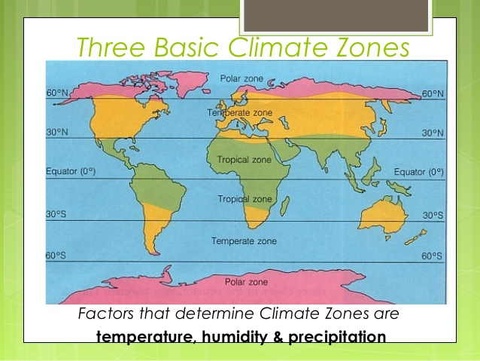
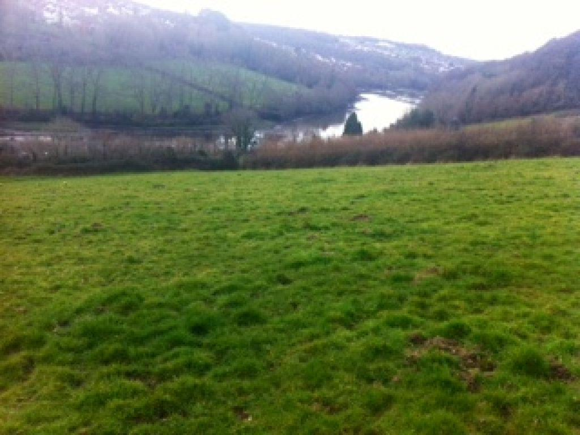
Tamerton Foliot, UK, Europe

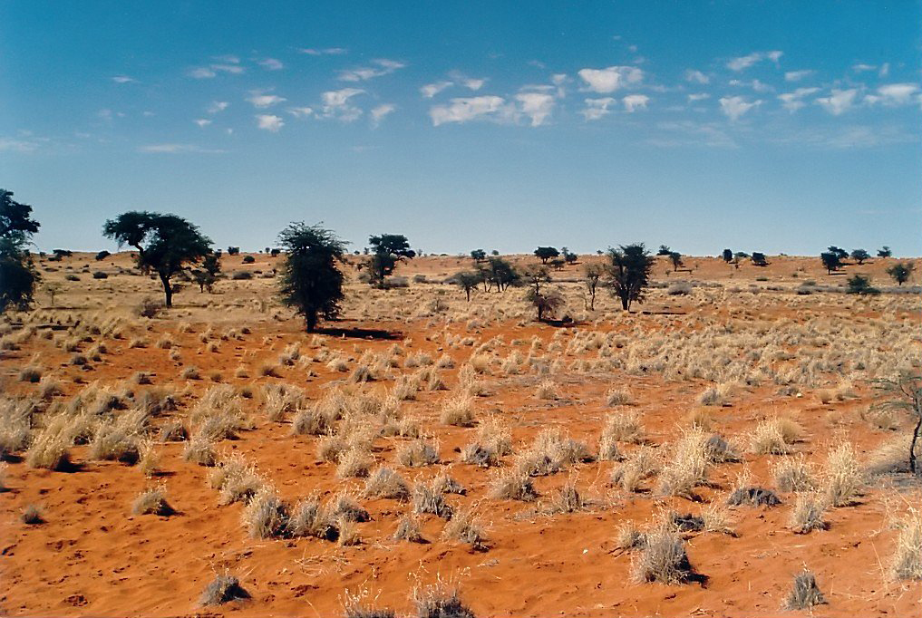
Kalahari Desert, Botswana, Africa

