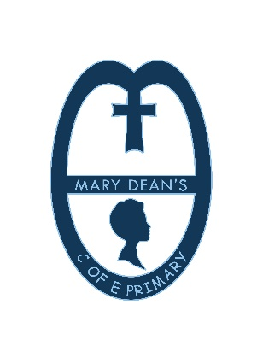 | Mary Dean’s CE Primary School  Teaching posts

Governors of our school are seeking to appoint outstanding teachers to join our happy and successful team.
We have two posts available.
For September 2021
- Maternity Cover in Key Stage One. Full time. MPS 1-4
- 0.8 teacher in upper Key Stage Two. Permanent. MPS 1-4
The successful applicant will be able to demonstrate the following:
- Outstanding classroom practice
- High aspirations and expectations for all pupils
- A deep knowledge of the relevant curriculum
- The ability to motivate and enthuse all pupils
- A commitment to the Church of England character of the school
- The will and drive to work in tandem with parents
- The ability to direct support staff effectively
- The ability to work co-operatively and collaboratively with staff across the whole team
- A love of learning
This post is suited to applicants at all stages of their career.

Closing date for all posts: Noon. Friday 14th May 2021
Interviews: Thursday 20th and Friday 21st May 2021

Interested applicants should see the school website for an application form and further details about each post.
All appointments are subject to full DBS checks.
Visits to the school are warmly welcomed. Please telephone the school for an appointment.
Please address your application to the Head Teacher, Mrs T Jones.

