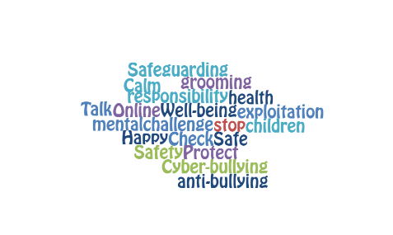
Support Staff Update Spring 2022

NAME: …………………………………………………………
Before session |  | After session
 | I know who the Designated Leads are for Safeguarding in my school
 | I know I am expected to have read part 1 of Keeping Children Safe in Education, September 2021, and where to find a copy
 | I know what the key areas of safeguarding are
 | I know about the importance of good mental health and how to promote this in school
 | I know what makes an unhealthy relationship
 | I am aware of the ‘INCEL’ movement and why it may pose a risk to primary pupils

Prior to the session:
Make a list of three things you might notice if a child is suffering abuse.

