Parable | A simple story said to have been told by Jesus to teach a moral lesson.
Belonging | To be a member of a particular group or organisation.
Religion | The belief in and worship of a personal God.
Love | A strong feeling of affection for someone or something.
Prayer | The religious act of talking to God to ask for guidance, forgiveness or to confess something.
Baptism | A Christian rite where a person has water applied to the forehead or the whole body is dipped in water to welcome them to the church.
Promise | When someone does what they say they will do.
Wedding | A ceremony where two people joined in union.
Hymns | Songs to a God to thank them or praise them.
Ceremony | A formal act performed in a regular way.
Community | A group of people with common interests.
Symbols | A letter, character or sign that is used instead of a word.
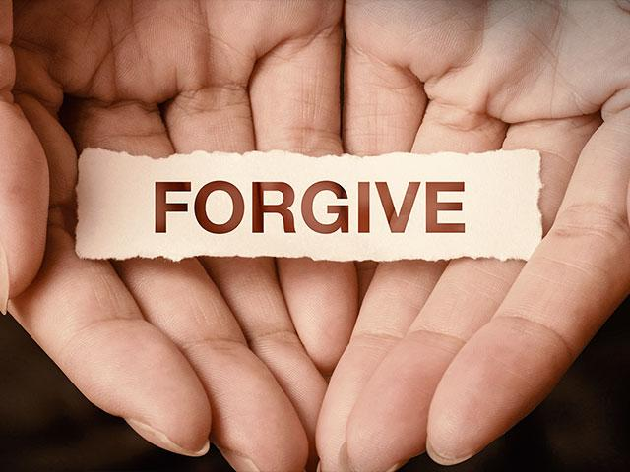
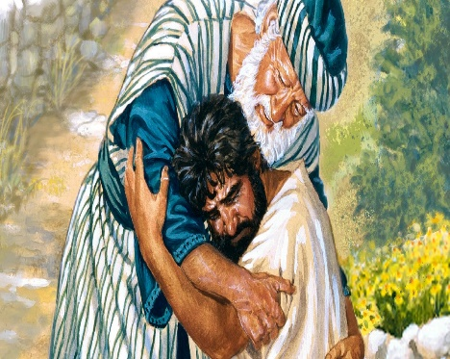
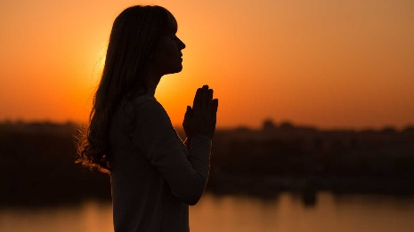
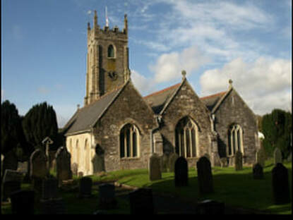
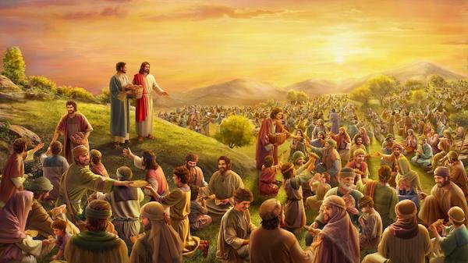
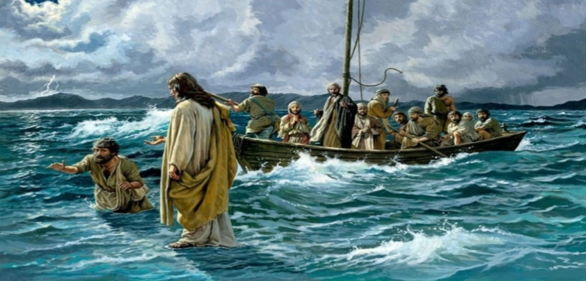
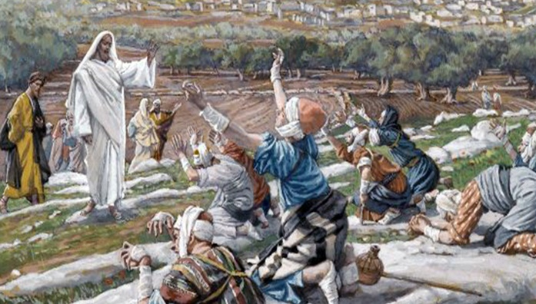
Year 1/2 RE. Cycle 1. Autumn Term 1. 2020. What does it mean to belong to a faith community?
Images.
Vocabulary Dozen
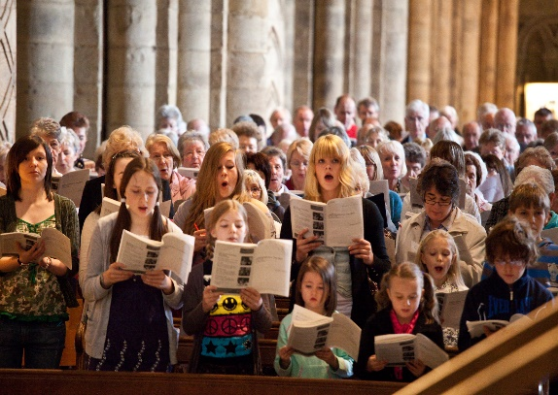
Week 1 | Week 2 | Week 3 | Week 4 | Week 5 | Week 6
What different groups can we belong to and what does it feel like to belong to them?  Discuss different groups – Cubs, Rainbows, After School club, gymnastics, swimming, family, Messy church etc. what does it feel like to part of it? (proud, fun, exciting, special) | What symbols are used to show that I belong?  Look at different Christian and compare with Hindu symbols  Discuss what they mean and why we might use them  (baptism candles, crosses as necklaces, fish/Ichthus badges, rosary, bible.  What symbols do we use in our everyday lives? | What does religion teach us to love one another?  Can we share our ideas? What have we learned? Jesus told his friends that everyone should love each other.  Hindus believe-This is the sum of duty: do nothing to others that would cause you pain if done to you.  Should we show love for others? Why? | How are we welcomed into a religion?  What happens when are welcomed somewhere? Show images/ video of Christian baptism. Discuss what is happening and why.  Compare with Hindu baby rites  -Jatakarma is performed to welcome the child into the family, | How do people show that they love someone?  Look at and compare images/ videos of wedding ceremonies. (Act out) Think about promises made, rings exchanged (Indian wedding- the priest, groom, bride and bride's parents sit beneath a mandap, a canopy)  Listen to music/hymns used at weddings- what do the words mean? | What are the benefits of belonging to a community?  Talk to others about how they express their identity and belonging in faith and other communities. Discuss what is good about being a community giving reasons for their ideas. Draw pictures and add quotes from people in different communities.
Gloucestershire agreed syllabus outcomes for unit:
Make sense of belief | Understand the impact | Make connections
- Recognise that loving others is important in lots of communities  - Say simply what Jesus and one other religious leader taught about loving other people | - Give at least two examples of a way in which Christians show their belief in God as loving and forgiving (e.g. by saying sorry, by seeing God as welcoming them back; by forgiving others).  - Give an example of how Christians put their beliefs into practice in worship (e.g. by saying sorry to God) | - Think, talk and ask questions about whether they can learn anything from the story for themselves, exploring different ideas.  - Give a reason for the ideas they have and the connections they make.

